**1.****Clip close**

**1.Preparation**

1.You need to a Clip version HelloBot.

2.You should learn about the correct method to install the Clip arm (angle correction).

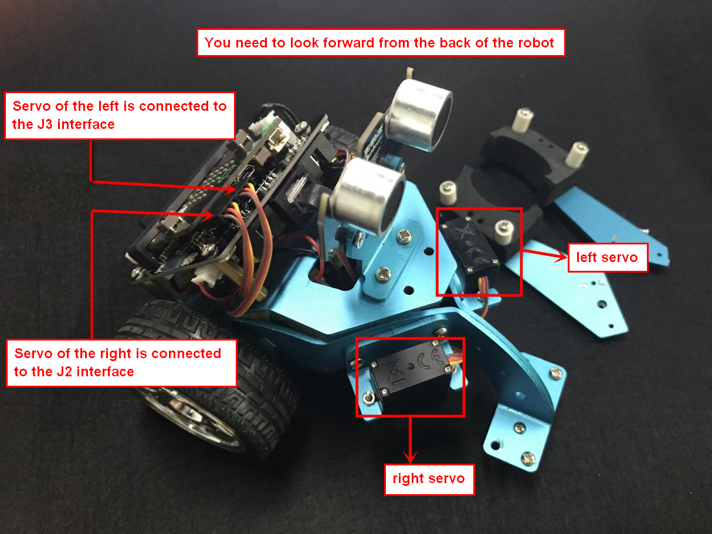

1-1 wiring of metal servo

You need to connect the wiring of the servo to the expansion board, and the servo of the left is connected to the J3 interface and the servo of the right is connected to the J2 interface. The brown line of the servo corresponds to GND, the red line corresponds to VCC, and the yellow line corresponds to IO.

You can connect the micro USB cable to the micro:bit and the computer. After successfully downloading the program, the servo will start to turn, and you'll have to wait for the servo to stop, which means that the servo number S1 turns to 0°, and the servo number S2 turns to 180°. Then you can close the left and right arms and lock the fixing screws. As shown in the following figure.

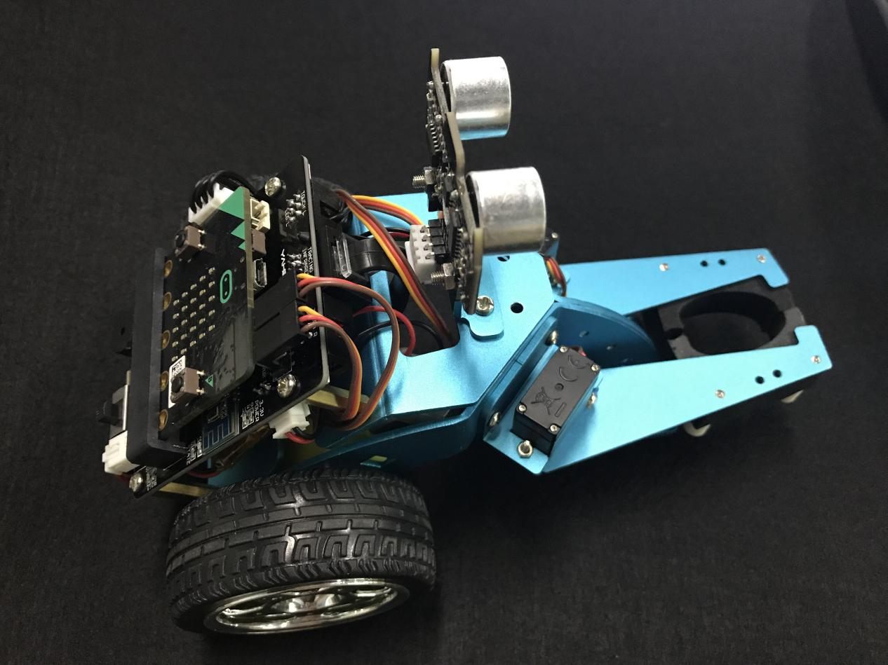

1-2 Installed successfully

1. **Learning goals**

In this course, we will learn how to control the robot complete **Clamp close,** and learn the angle of the servo when the Clamp close.

**3.Programming**

3.1 Programming online

**1) You should use the USB cable to connect the micro:bit to the computer, at this point, the computer will have a micro:bit U disk. You need to open it, click micro:bit website, then entered the micro:bit website** or you can enter the URL directly in your browser: http://microbit.org/

2) After entering the programming interface, you need to click Add package and copy the HelloBot package URL: https://github.com/lzty634158/HelloBot to the input field, click to confirm the add package. Then you can use the blocks of the HelloBot package.

3.2 Programming offline

1) You can double-click to use it. As shown in the following figure.

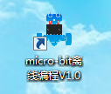

2) After entering the programming interface, you need to click Add package and copy the HelloBot package URL: https://github.com/lzty634158/HelloBot to the input field, click to confirm the add package. Then you can use the blocks of the HelloBot package.

Note: The package only needs to be added once. If you have added packages in the previous lessons, this course does not need to be added repeatedly.

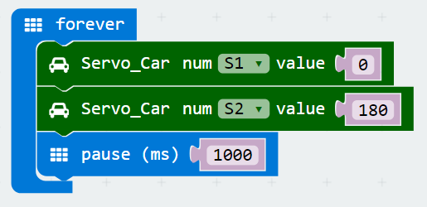

1-3 total program

The locations of blocks in the total program are shown in the following figure.

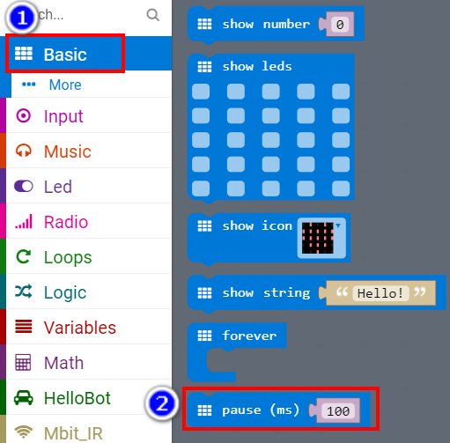

1-4

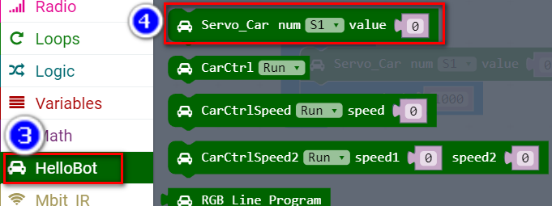

1-5

**4.Download programming**

You need to make sure that the micro:bit development board is connected to the computer. Then you should click on the download in the lower left corner as shown in 1-6 to download the program to micro:bit.

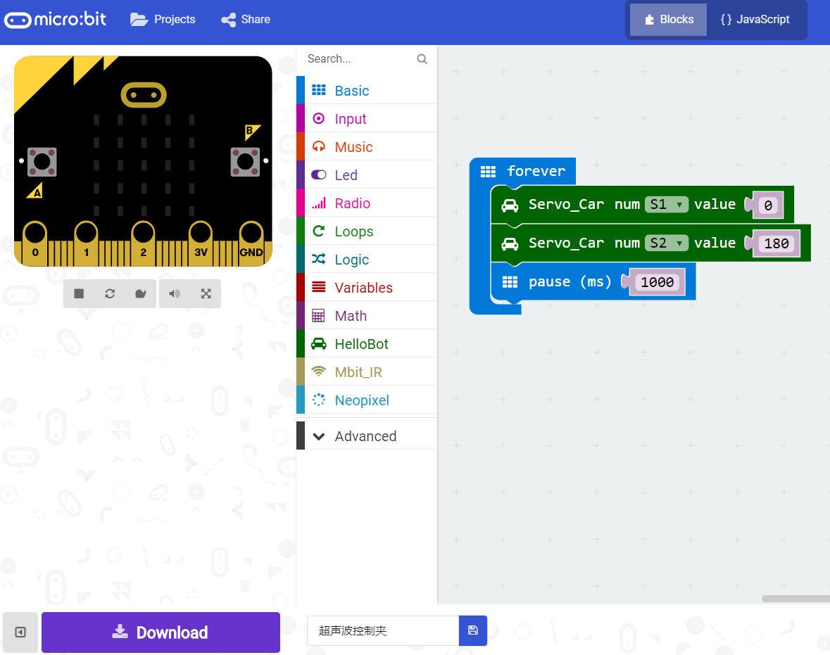

1-6

**5.Phenomenon**

After the code is uploaded. First, we need to manually open the clamp, as shown in figure 1-7. Then we can start to HelloBot, you can see that the clip will close, as shown in figure 1-8.

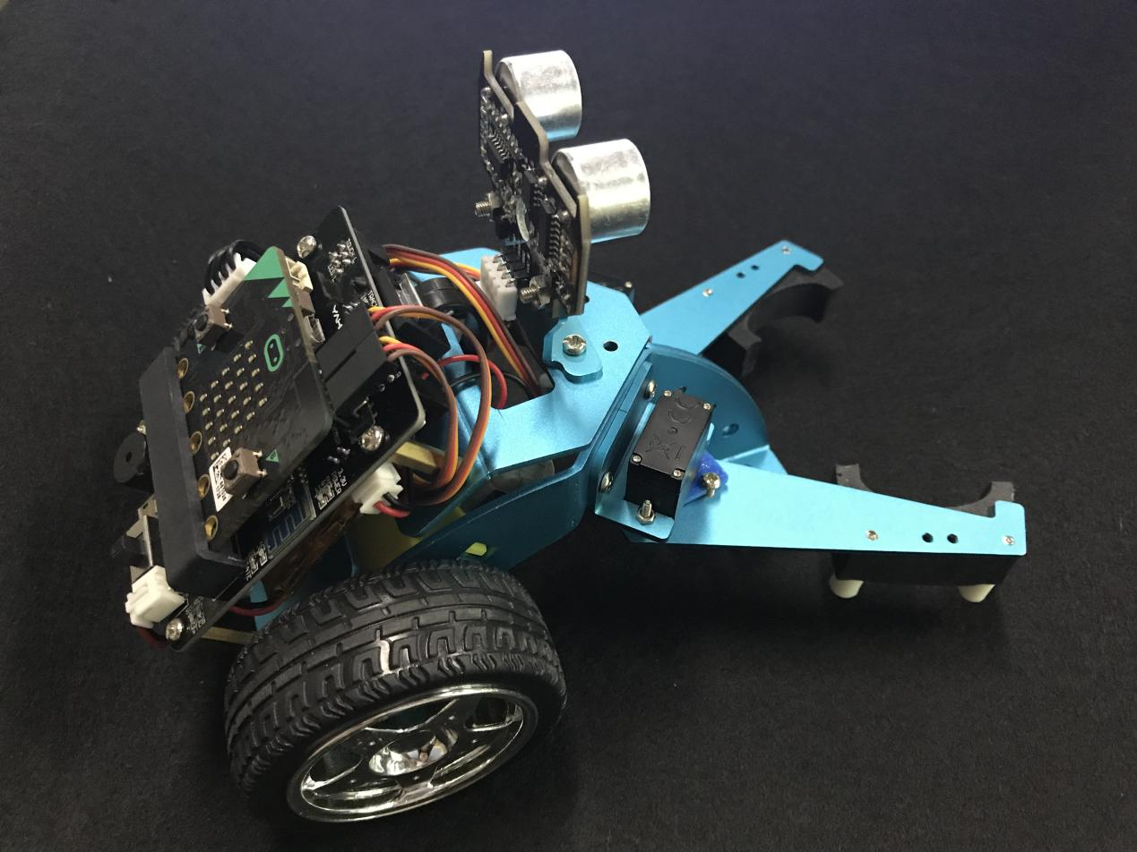

1-7

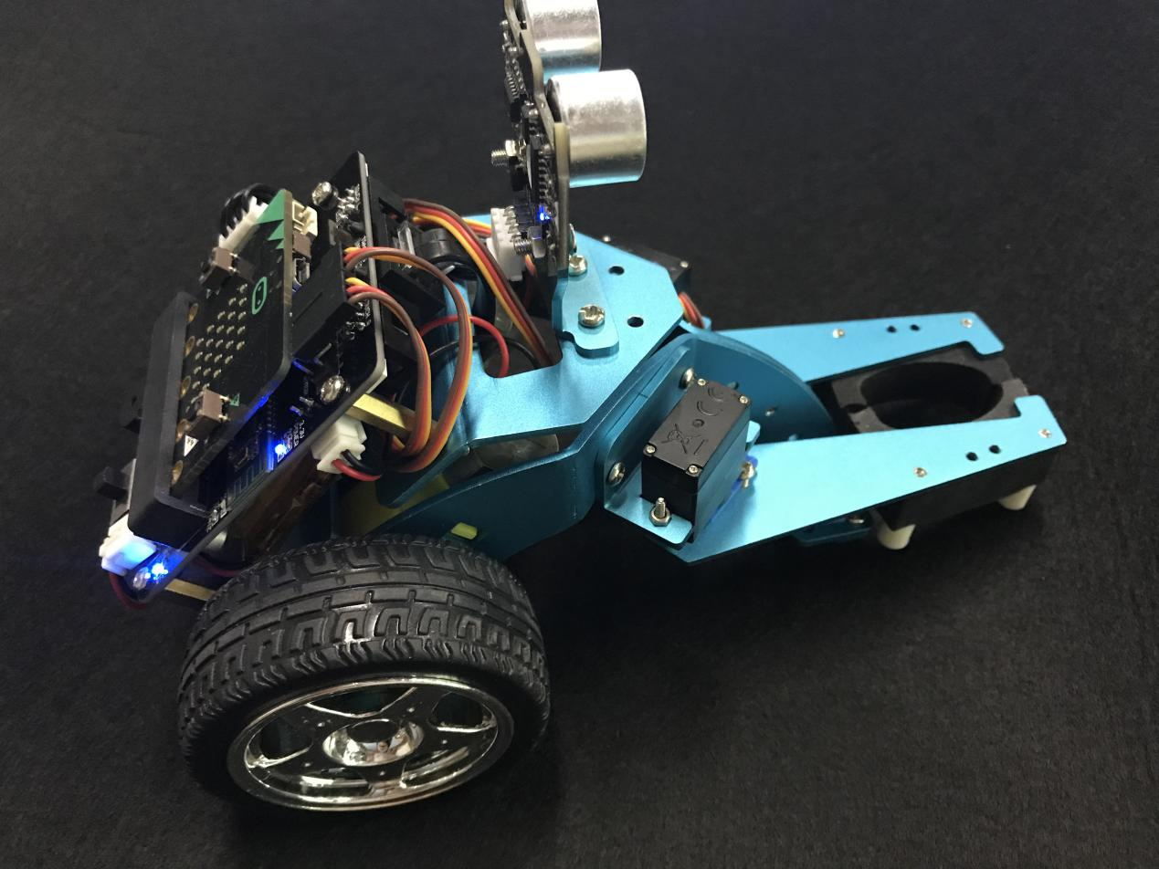

1-8